56x+72y=40
7x+9y=5, gcd(7,5)=1, 1I5
. a=7 b=9 c=5


X₀=2 Y₀ = -1
X= 2+(9/1) t= 2+9t
Y= -1 –(7/1)t= -1 -7t
t | x | y
-1 | -7 | 6
0 | 2 | -1
1 | 11 | -8

c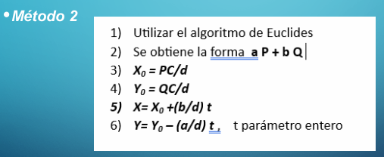
7x+9y=5, gcd(7,9)=1, 1I5
. a=7 b=9 c=5
9 I_7_ 9=7*1+2, 9-7*1=2
2 1

7 I_2_ 7=2*3+1, 7-2*3=1, 7-(9-7*1)*3=1, 7-9*3 +7*3=1,
1 3 (7+7*3)-9*3=1
7(1+3)-9*3=1
2 I_1_ 7*4 + 9(-3)=1
0 2 P=4 Q=-3

X₀=PC/d=4*5/1=20
Y₀=QC/d=-3*5/1=-15
X= 20+ (9/1)t = 20+9t
Y= -15 –(7/1)t= -15-7t
t | x | y
-1 | 11 | -8
0 | 20 | -15
1 | 29 | -22



X: cant pavos
Y: cant corderos
Z: cant cerdos

X+y+z=100, z=100-x-y
120x+50y+25z=4000, 24x+10y+5z=800

24x+10y+5(100-x-y)=800
24x+10y+500-5x-5y=800
19x+5y=300 ec diofántica, gcd(19,5)=1, 1I300
.a=19, b=5, c=300, d=1
Metodo1
X₀=0 , y₀ =60
X= 0+ (5/1)t=5t
Y= 60 – (19/1)t= 60-19t
t | x | y | z
1 | 5 | 41 | 54
2 | 10 | 22 | 68
3 | 15 | 3 | 82

19x+5y=300 ec diofántica, gcd(19,5)=1, 1I300
.a=19, b=5, c=300, d=1
Método 2
19 I_5_ 19=5*3+4, 19-5*3=4
4 3

5 I_4_ 5=4*1 +1, 5 - 4*1=1, 5 –(19 -5*3)*1=1
1 1 5- 19*1 +5*3 =1
(5 +5*3) -19*1=1
4 I_1_ 5(1+3) -19*1=1
0 4 5*4-19*1=1
19(-1)+5*4 =1
P=-1, Q=4


X₀=-1*300/1=-300
Y₀=4*300/1=1200

X= -300 +(5/1)t
Y= 1200-(19/1)t=1200-19t
t | x | y | z
61 | 5 | 41 | 54
62 | 10 | 22 | 68
63 | 15 | 3 | 82

